**HOTEL-MANAGEMENT-SYSTEMs**

It is a Back-End Project which is Completely Based on Hibernate (Includes all Mapping with CRUD operations)

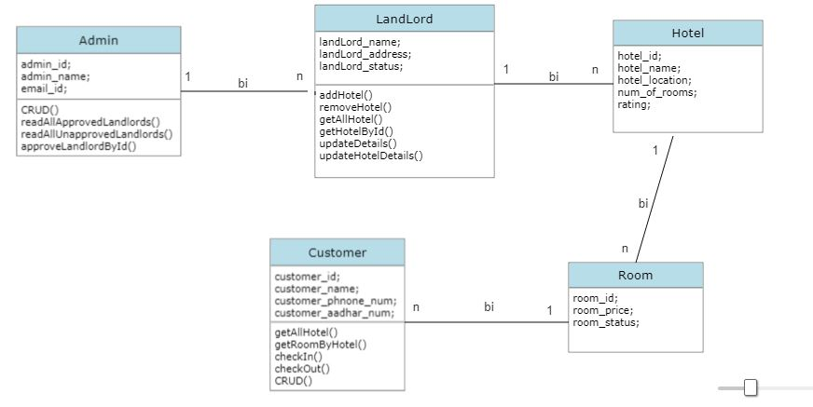

### About The Project:-

1. Hotel Management System is an back-end project based on Hibernate Framework.
2. It inculdes all Mapping Associations.
3. This project has 5 Modules are as Follows:  
   1. **Admin**  
   2. **LandLord**  
   3. **Hotel**  
   4. **Rooms**  
   5. **Customer**

### 4.Roles:-

* 1. **Admin** role is to approve all the lanlord property i.e hotel. If the property get approved by admin then only it should visible for customers.
  2. **Landlord** role is manage(CRUD-operations) all its property i.e. Hotels
  3. **Hotel** role is to approve all the rooms wheather it is available or not for customers.
  4. **Customers** role is to book rooms.

### Tools and Technologies used:-

1. Eclipse IDE
2. Maven 4.0
3. MySQL 8.0
4. Hibernate
5. Java

### Packages & Class:-

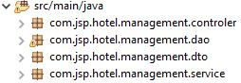

1. Total 4 package is present  
   a. **Controller** contains all the class which is used to perform crud operation.  
   b. **Dao** contains all the class which is used for Data Access Object.  
   c. **Dto** contains all the class which is used for Data Transfer Object.  
   d. **Services** contains all the class for business logic.

### All Tables from Database(MySQL);-

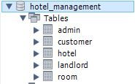

1. **Admin Table**

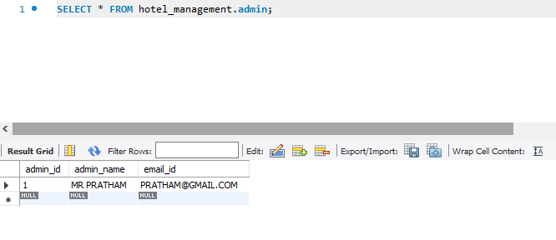

1. **Landlord Table**

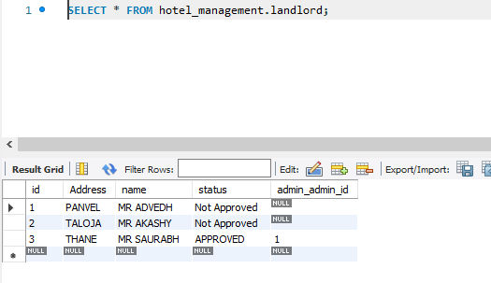

3. **Hotel Table**

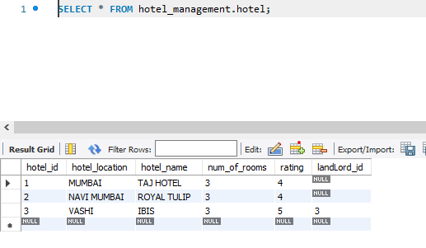

**4.Room Table**

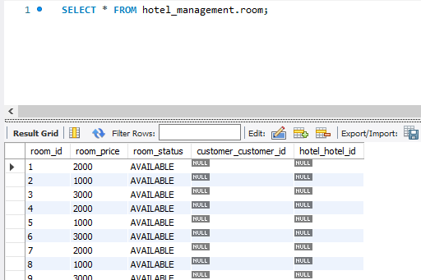

**5.Customer Table**

